1. SELECT obat.id, nama_obat, stok, harga_jual, com_supplier

FROM `obat`

**JOIN** supplier ON obat.id_supplier = supplier.id

ORDER BY id ASC

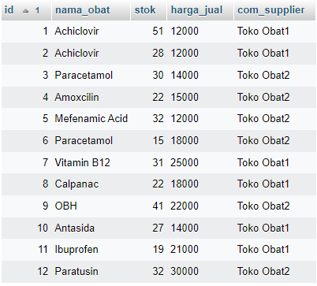

1. SELECT obat.id, nama_obat, jenis_obat, stok, harga_jual

FROM `obat`

**JOIN** jenis ON obat.id_jenis = jenis.id

ORDER BY id ASC

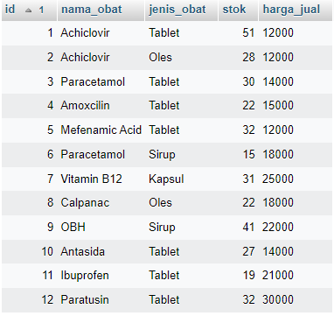

1. SELECT obat.id, nama_obat, stok, harga_jual, com_supplier, alamat, kota

FROM `obat`

**JOIN** supplier ON obat.id_supplier = supplier.id

**WHERE** kota LIKE '%a%'

ORDER BY id ASC

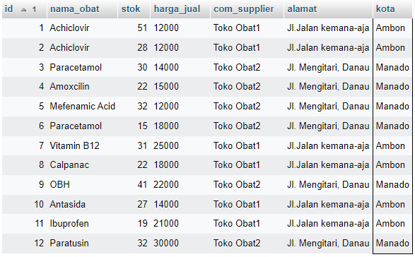

1. SELECT obat.id, nama_obat, stok, harga_jual, com_supplier, alamat, kota

FROM `obat`

**RIGHT JOIN** supplier ON obat.id_supplier = supplier.id

**WHERE** kota LIKE '%a%'

ORDER BY id ASC

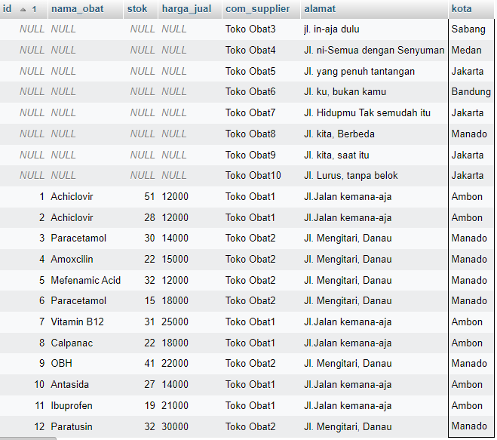

1. SELECT obat.id, nama_obat, stok, harga_jual, com_supplier

FROM `obat`

**LEFT JOIN** supplier ON obat.id_supplier = supplier.id

ORDER BY id ASC

